**Name:** Shivam Verma

**Course:** B.Sc. (H) Computer Science

**Semester:** 5th

**College Roll No.:** 19HCS4048

**Subject:** Data Analysis and Visualization

**Q5. Taking Iris data, plot the following with proper legend and axis labels: (Download IRIS data from: https://archive.ics.uci.edu/ml/datasets/iris or import it from sklearn.datasets):**

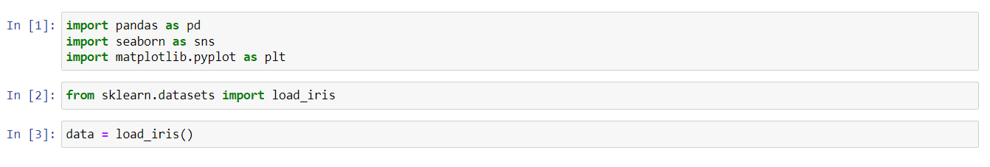

1. **Plot bar chart to show the frequency of each class label in the data.**

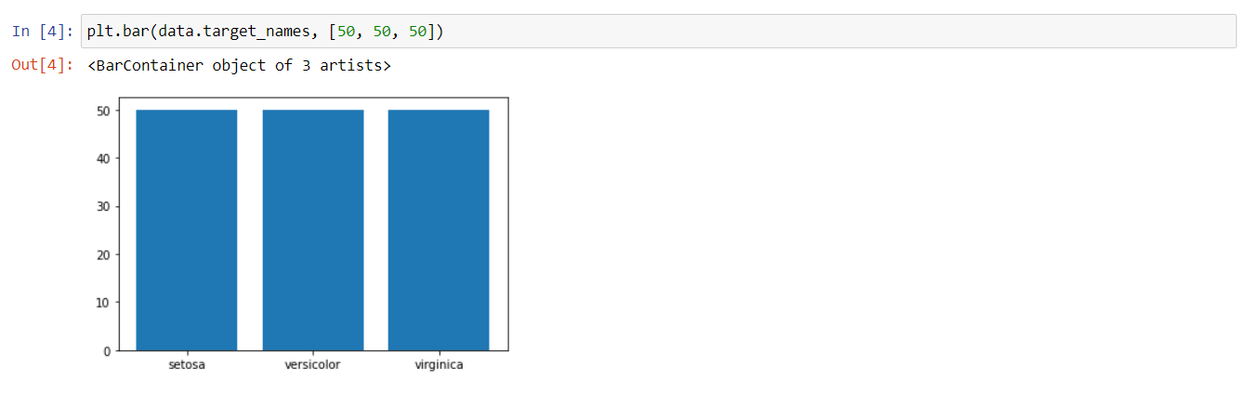

1. **Draw a scatter plot for Petal width vs sepal width.**

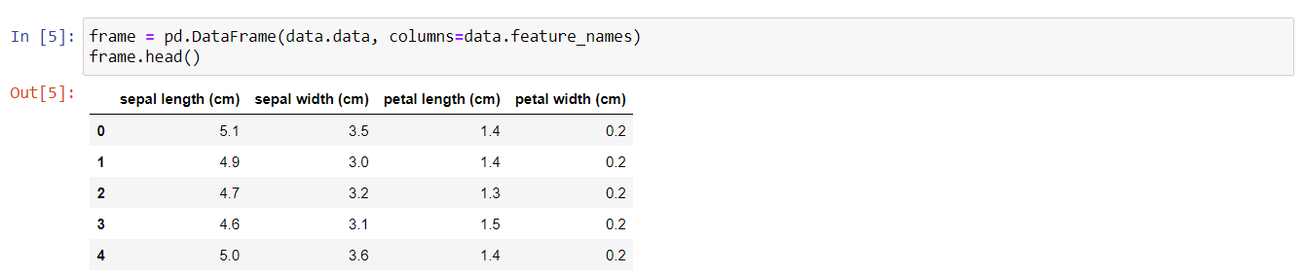

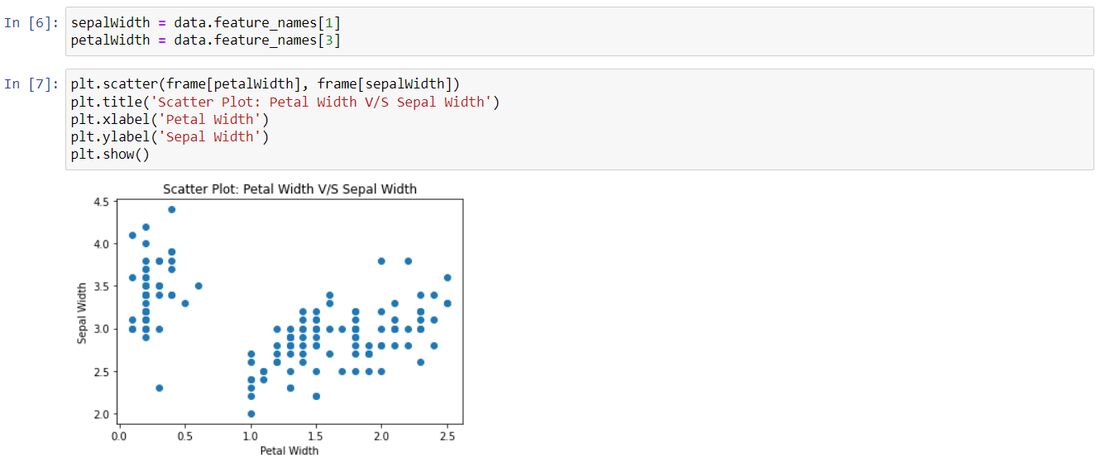

1. **Plot density distribution for feature petal length.**

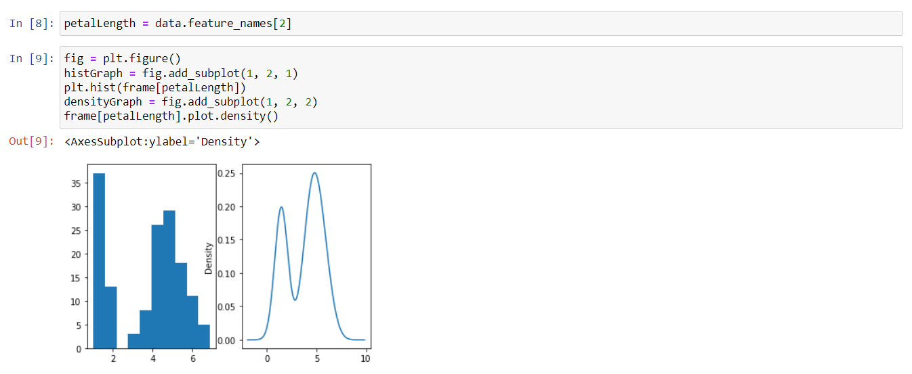

1. **Use a pair plot to show pairwise bivariate distribution in the Iris Dataset.**



